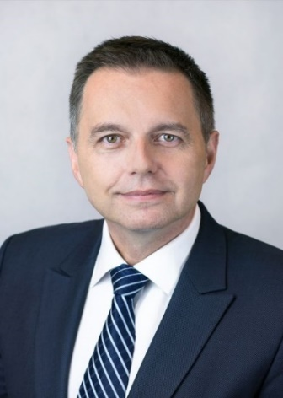 | Calendar of Peter Kažimír  Governor of Národná banka Slovenska and member of the ECB’s Governing Council  August 2023
Date | Meeting / Event | Location

The calendar gives information on Mr. Kažimír’s meetings in his capacity as a member of the ECB’s Governing Council. It includes institutional meetings, speaking engagements, attendance at conferences and events, as well as appointments with external parties (incl. media), unless releasing the information could undermine the protection of public interests recognised at EU level. Internal Eurosystem meetings are not published.

