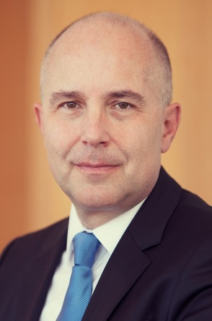 | Calendar of Vladimír Dvořáček  Member of Národná banka Slovenska Bank Board and Member of the Supervisory Board of the Single Supervisory Mechanism  May 2022
Date | Meeting / Event | Location
Thursday, 12 May | Supervisory Board | Athens, Greece
Friday, 13 May | Supervisory Board | Athens, Greece
Monday, 30 May | Meeting with media | Bratislava

The calendar gives information on Mr. Dvořáček´s meetings in his capacity as a member of the ECB’s Supervisory Board. It includes institutional meetings, speaking engagements, attendance at conferences and events, as well as appointments with external parties (incl. media), unless releasing the information could undermine the protection of public interests recognised at EU level. Internal Eurosystem meetings are not published.

