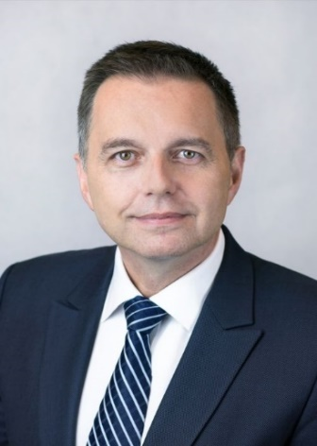 | Calendar of Peter Kažimír  Governor of Národná banka Slovenska and member of the ECB’s Governing Council  July 2026
Date | Meeting / Event | Location
Wednesday, July 1 | ECB Forum on Central Banking 2026  “Shaping Europe’s future: innovation, growth and stability” - conference | Sintra, Portugal
Tuesday, July 21 –  Thursday, July 23 | Governing Council ECB - meeting | Frankfurt am Main, Germany

The calendar gives information on Mr. Kažimír’s meetings in his capacity as a member of the ECB’s Governing Council. It includes institutional meetings, speaking engagements, attendance at conferences and events, as well as appointments with external parties (incl. media), unless releasing the information could undermine the protection of public interests recognized at EU level. Internal Eurosystem meetings are not published.

