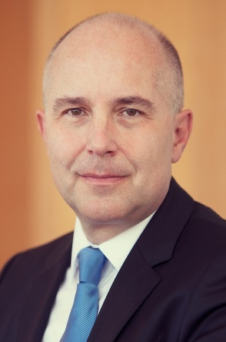 | Calendar of Vladimír Dvořáček  Member of Národná banka Slovenska Bank Board and Member of the Supervisory Board of the Single Supervisory Mechanism  August 2023
Date | Meeting / Event | Location
Wednesday, August 16 | How households can handle the increase in mortgage payments - Press conference | Bratislava

The calendar gives information on Mr. Dvořáček´s meetings in his capacity as a member of the ECB’s Supervisory Board. It includes institutional meetings, speaking engagements, attendance at conferences and events, as well as appointments with external parties (incl. media), unless releasing the information could undermine the protection of public interests recognised at EU level. Internal Eurosystem meetings are not published.

