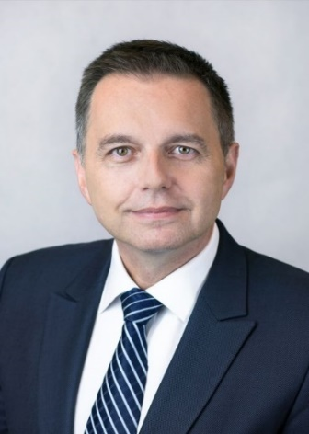 | Calendar of Peter Kažimír  Governor of Národná banka Slovenska and member of the ECB’s Governing Council  May 2022
Date | Meeting / Event | Location
Wednesday, May 4 | Governing Council | Frankfurt am Main, Germany
Sunday, May 8 | Bank for International Settlement (BIS) colloquium | Basel, Switzerland
Tuesday, May 10 – Thursday, May 12 | European Bank for Reconstruction and Development (EBRD) Annual Meetings | Morocco
Friday, May 13 | Social event for International Monetary Fund (IMF) delegation | Bratislava
Wednesday, May 18 | Governing Council & Banking Industry dialog - teleconference | Bratislava
Thursday, May 19 | Meeting with EU ambassadors on inflation in eurozone and financial stability | Bratislava
Thursday, May 19 | Schumpeter Award 2022 | Vienna, Austria
Thursday, May 26 – Saturday, May 29 | Bank Board meeting – National bank of Slovakia & Banka Slovenije | High Tatras, Slovakia

The calendar gives information on Mr. Kažimír’s meetings in his capacity as a member of the ECB’s Governing Council. It includes institutional meetings, speaking engagements, attendance at conferences and events, as well as appointments with external parties (incl. media), unless releasing the information could undermine the protection of public interests recognised at EU level. Internal Eurosystem meetings are not published.

